**Cylinder and Sphere Sensor Interactivity (with javascript)**

Tests for the Cylinder and Sphere Sensor using JavaScript to control properties of other objects.

**cylSensor_CtrlLtColor.x3d**

This demo has the 3 Cylinders control the Red, Green and Blue color of the DirectionalLight in the scene. It begins with the RGB color set to (.5, .5, .5). Each cylinder can be dragged between -1 and 1 radians, setting each color between 0 and 1 respectively. Figure 2 has RGB set to 1 radian for RGB (1, 1, 1).

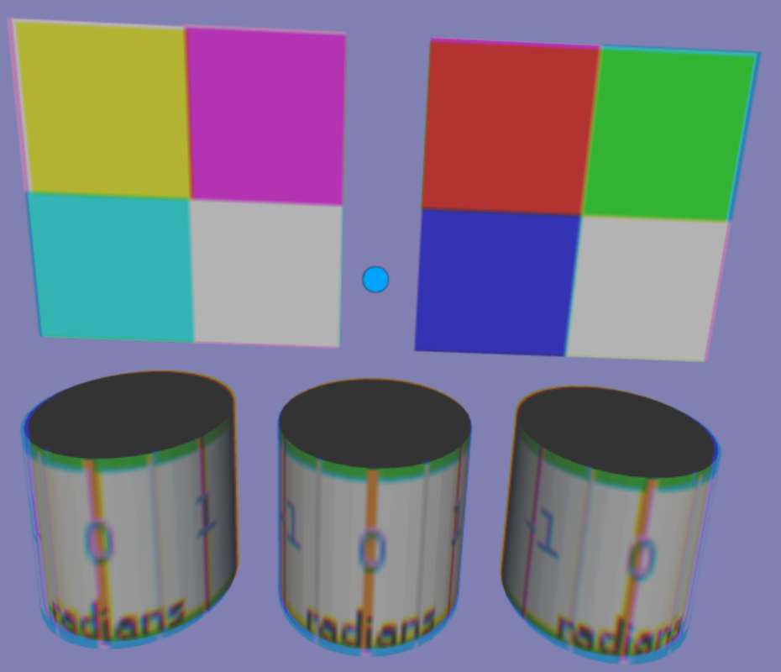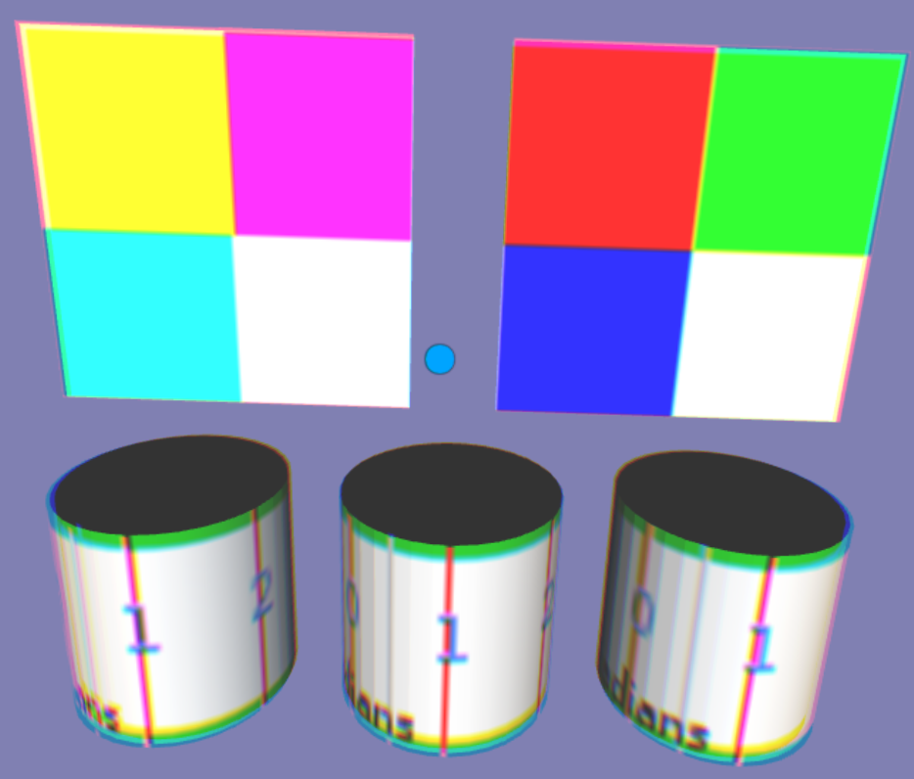

In this scene, the RGB is set to (0, 1, 1) and in the last scene, the RGB is set to (1, 0, 1).

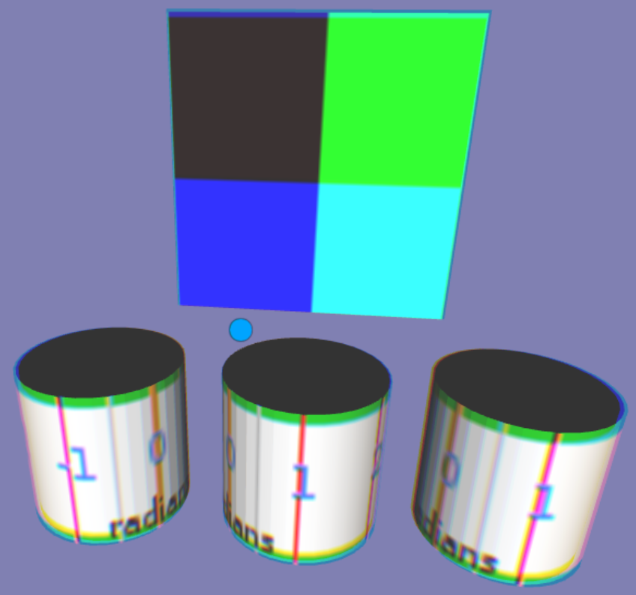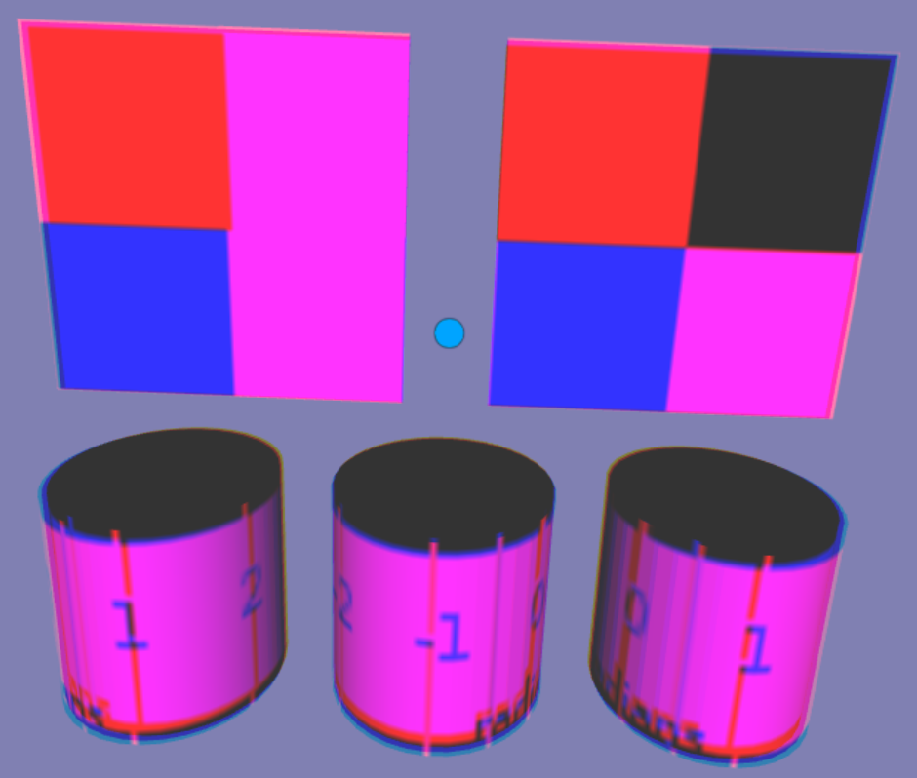

**cylSensor_CtrlMaterial.x3d**

This demo controls the diffuseColor of the Red-Green-Blue-White panel. Initially the diffuseColor is to to (.5, .5, .5). The Cylinders rotate between -1 and 1 radian, controlling the RGB of the panels diffuse Color. In the second scene, Cylinders are each rotated to 1 radian setting the diffuseColor to (1, 1, 1).

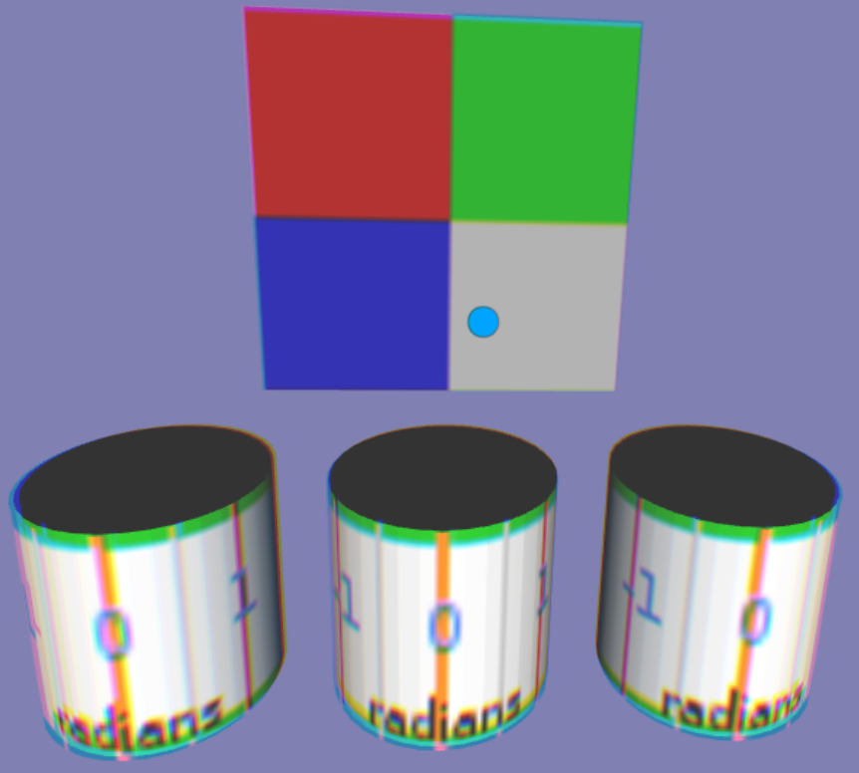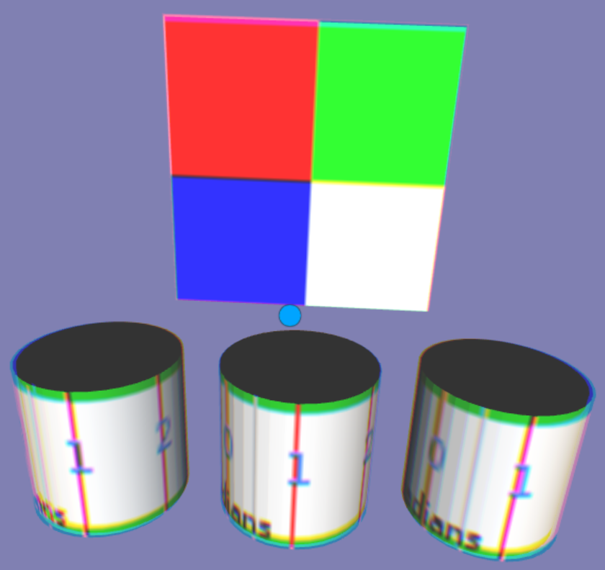

In this final scene, Red Cylinder is rolled to -1 radian and thus the diffuseColor is (0, 1, 1).



**cylSensor_CtrlRotation.x3d**

The Cylinders control the X, Y and Z rotation of the color box in the background. Each Cylinder rotates between -3.14 to 3.14 radians. The initial scene, each Cylinder is set to 0 radians for no rotations. In the second scene, the box is rotated around the x-axis about 2.5 radians.

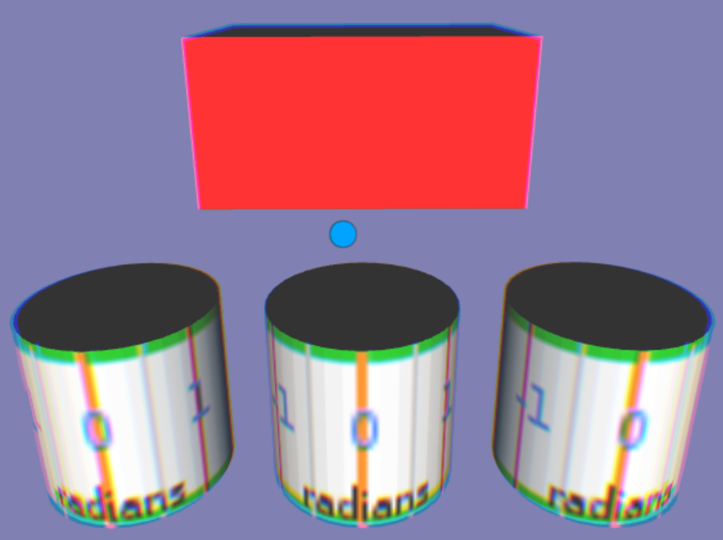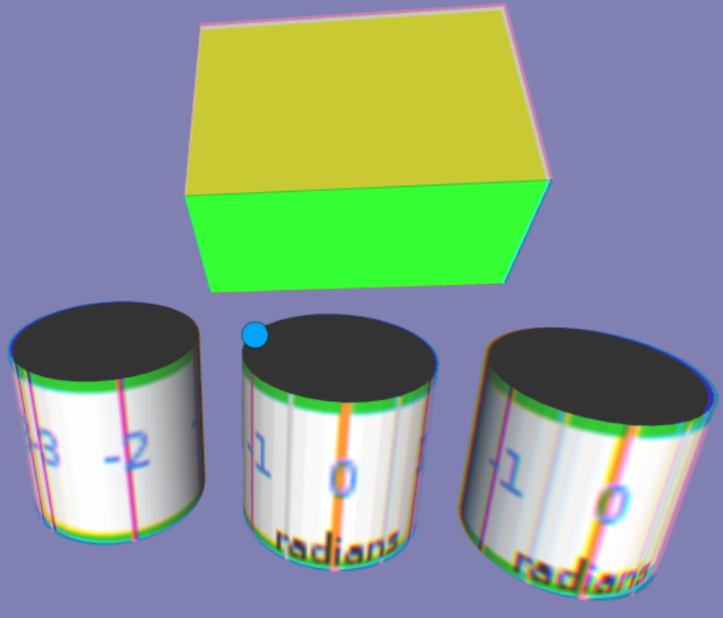

The next scene the color box is rotated 2 radians around the y-axis. The last scene has the color box rotated about 2.5 radians around the z axis.

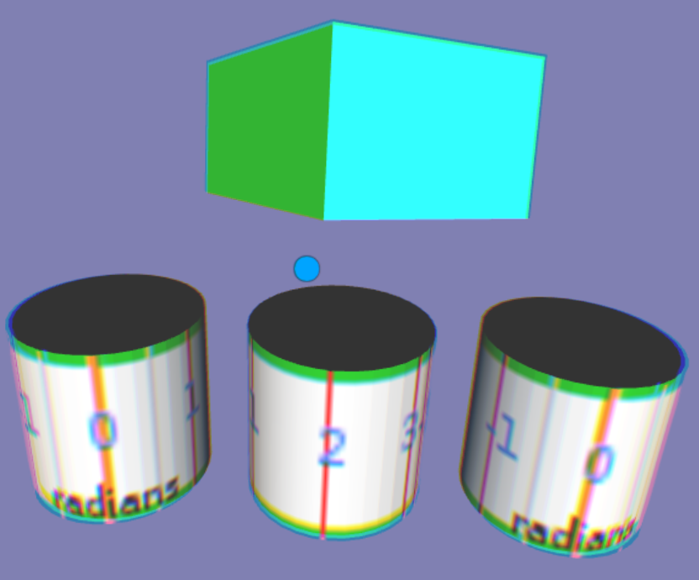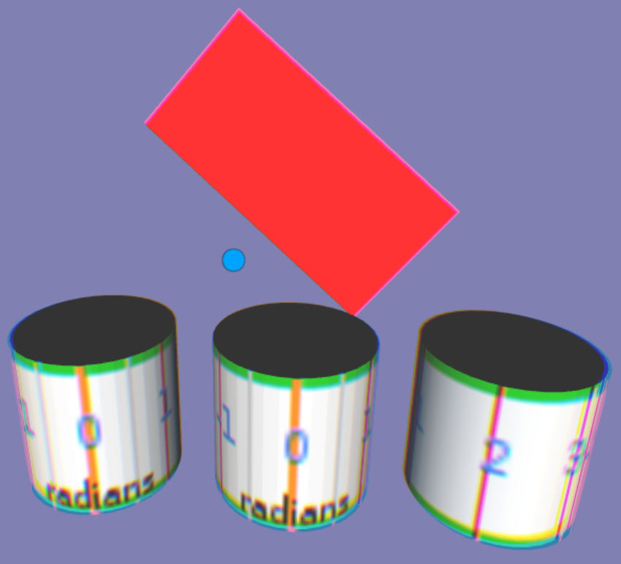

**cylSensor_CtrlTextureTransform.x3d**

The Cylinders control texture transformations. The upper left and upper right Cylinders control the X and Y translations of the texture maps. In scene 2, the X translation is about .8, and the Y translation is about .6.

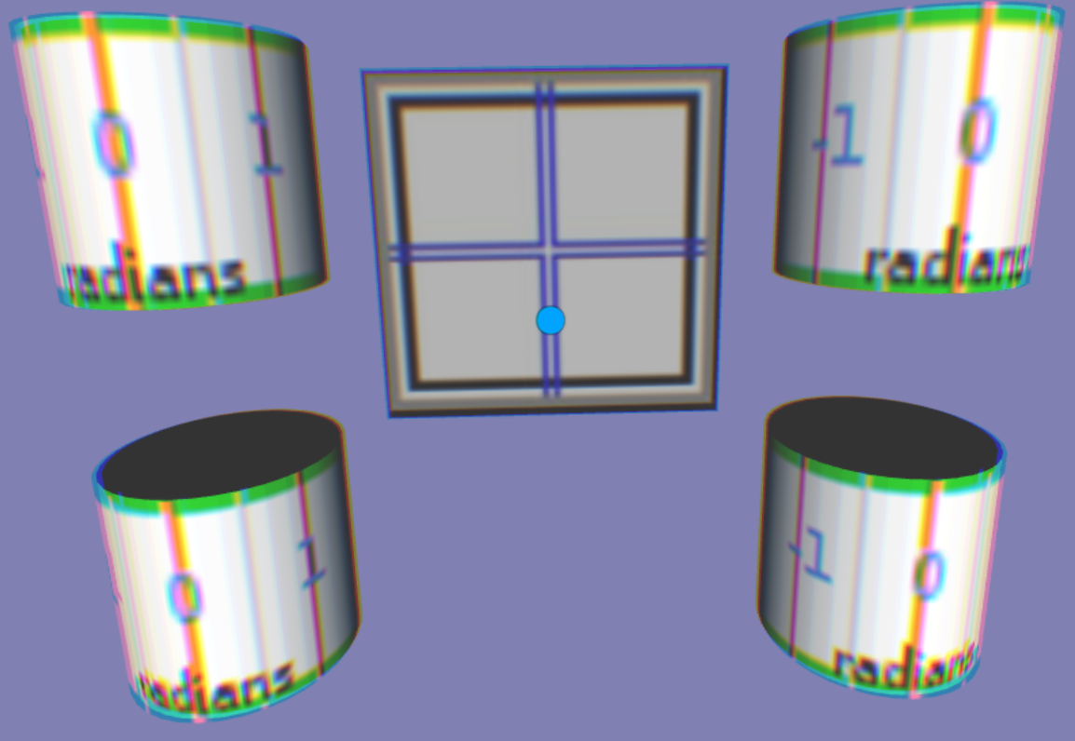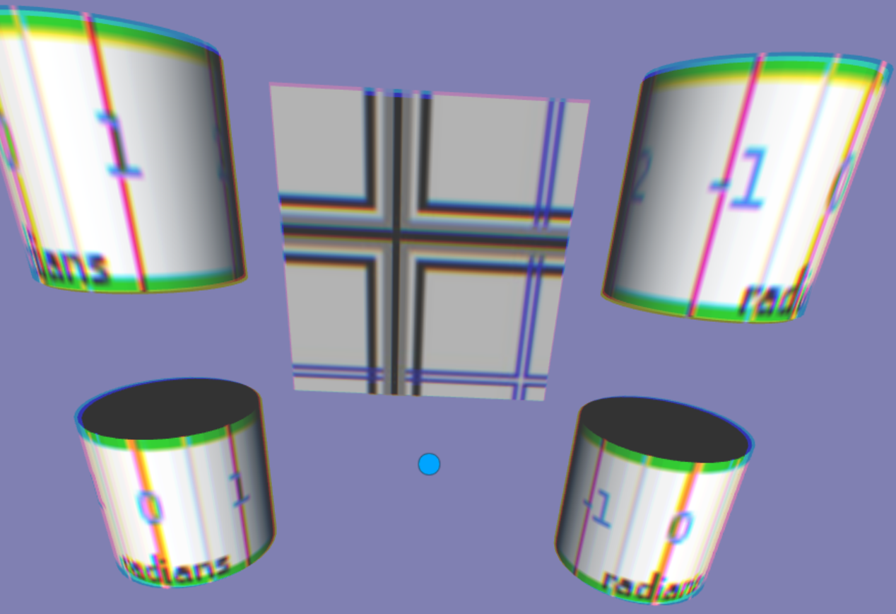

The lower left Cylinder controls a uniform scale on the texture map. The formula is to square the rotation in radians + 1. The Cylinder is rotated 1 radian, then add 1 for a total of 2, and then square it for a scaling of 4.

The lower right Cylinder rotates the texture map by the numer of radians, in the case, a rotation of about 2.5 radians.

